Insertion Sort

Insertion sort is a simple sorting algorithm that works similar to the way you sort playing cards in your hands. The array is virtually split into a sorted and an unsorted part. Values from the unsorted part are picked and placed at the correct position in the sorted part.

**Algorithm**  
To sort an array of size n in ascending order:  
1: Iterate from arr[1] to arr[n] over the array.  
2: Compare the current element (key) to its predecessor.  
3: If the key element is smaller than its predecessor, compare it to the elements before. Move the greater elements one position up to make space for the swapped element.

# **Example:**

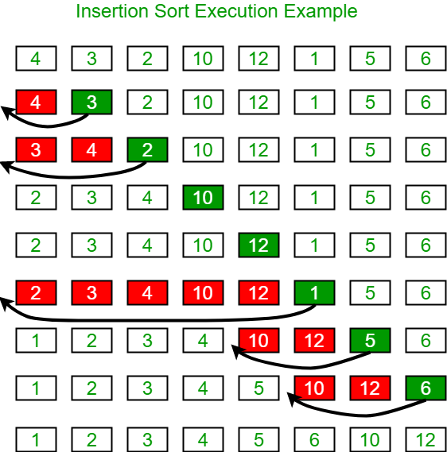

**Another Example:**  
**12**, 11, 13, 5, 6

Let us loop for i = 1 (second element of the array) to 4 (last element of the array)

i = 1. Since 11 is smaller than 12, move 12 and insert 11 before 12  
**11, 12**, 13, 5, 6

i = 2. 13 will remain at its position as all elements in A[0..I-1] are smaller than 13  
**11, 12, 13**, 5, 6

i = 3. 5 will move to the beginning and all other elements from 11 to 13 will move one position ahead of their current position.  
**5, 11, 12, 13**, 6

i = 4. 6 will move to position after 5, and elements from 11 to 13 will move one position ahead of their current position.  
**5, 6, 11, 12, 13**

<https://www.geeksforgeeks.org/insertion-sort/>